Implementing the Multi-Level Feedback Queue (MLFQ) Scheduler by Combining Semaphores and Monitors
A Technical Article on Hybrid Synchronization in Operating-System Scheduling

Document Information
Field | Details
Title | Implementing the MLFQ Scheduling Algorithm by Combining Semaphores and Monitors
Authors | Najla Davarpanah
Course | Embedding Systems
Instructor | Majid Shamshirgaran
University / Institution | Eshragh University
Date | October 2026
Version | 1.0
Keywords | MLFQ, Scheduling, Semaphore, Monitor, Hybrid Synchronization, Multicore, Operating Systems

Abstract
Semaphores and monitors each solve a different part of the synchronization problem in an MLFQ scheduler. Monitors are excellent at protecting compound data structures such as the ready queues together with the policy that manipulates them. Semaphores are excellent at counting resources, such as free CPU cores, and at signaling from contexts that must never block on a lock, such as a timer interrupt handler. This article presents a hybrid MLFQ design that assigns each tool to the job it does best. A monitor owns the queues, the ready counter and the scheduling policy; a counting semaphore limits the number of processes that run at the same time to the number of cores; and a second semaphore carries timer ticks from the interrupt handler to a booster thread that performs the priority boost. We give the architecture, pseudocode, a flowchart, a worked two-core example, a correctness argument covering deadlock and starvation, and a comparison of all three approaches in this series.

1. Introduction
The two earlier articles in this series implemented MLFQ with semaphores only and with a monitor only. Each has a weakness. The semaphore-only version needs many locks and a strict lock order, and a single forgotten signal breaks it. The monitor-only version is easy to read, but a monitor is a poor fit for two things a real kernel needs: counting how many cores are free, and waking a thread from an interrupt handler, which is not allowed to sleep or wait for a lock.
The hybrid design resolves this by division of labor:
- The monitor guards all shared scheduling state and implements the MLFQ policy.
- Semaphores model counted resources and carry asynchronous signals.
The key rule that keeps the combination safe is simple: a thread never waits on a semaphore while it is inside the monitor.

2. Background

2.1 MLFQ Rules
Rule | Description
R1 | If Priority(A) > Priority(B), A runs and B does not.
R2 | If Priority(A) = Priority(B), they run in Round Robin using the quantum of that queue.
R3 | A new process enters the highest-priority queue.
R4 | A process that uses its whole quantum moves down one queue.
R5 | After a period S, all processes move to the top queue (priority boost).

2.2 Strengths of Each Tool
Need | Semaphore | Monitor
Protect several related variables and a policy together | Awkward, needs several locks | Natural, one module
Count identical resources (free cores) | Natural, counting semaphore | Awkward, needs a counter plus a condition
Remember a signal sent before anyone waits | Yes, the count remembers | No, a condition signal is lost
Signal from an interrupt handler | Yes, signal never blocks | No, entering a monitor may block
Wait for a complex condition (for example, queue not empty) | Possible, but indirect | Natural, while (!cond) wait(c)
Prevent forgotten unlock | No | Yes, lock is implicit
The table shows that the strengths are complementary, which motivates the hybrid.

3. System Model
The system has M cores and a pool of W worker threads with W at least M. Each worker repeatedly takes a process from the scheduler and runs it for one quantum on a core. There are N = 3 queues.
Queue | Priority | Time quantum | Policy
Q0 | Highest | 4 ms | Round Robin
Q1 | Medium | 8 ms | Round Robin
Q2 | Lowest | 16 ms | FCFS
The process control block is the same as before:
Field | Type | Meaning
pid | int | Unique process identifier
level | int | Current queue index
remaining | int | Remaining CPU burst time
state | enum | NEW, READY, RUNNING, WAITING, TERMINATED

4. Hybrid Design

4.1 Division of Responsibility
Component | Mechanism | Responsibility
Q[0..N-1], ready_count | Monitor MLFQ (private data) | Hold all ready processes
make_ready, get_next, update_after_run, boost | Monitor entry procedures | Implement the MLFQ policy under mutual exclusion
nonEmpty | Condition variable in the monitor | Workers sleep here while no process is ready
cpu_slots | Counting semaphore, initial value M | Limits simultaneous running processes to M
boost_sem | Binary semaphore, initial value 0 | Carries the timer tick to the booster thread

4.2 Threads
Thread | Count | Role
Worker | W | Takes a process from the monitor, acquires a core slot, runs one quantum, returns the process
Booster | 1 | Sleeps on boost_sem; on each tick calls MLFQ.boost()
Timer interrupt handler | 1 per tick | Calls signal(boost_sem) only; never enters the monitor

4.3 Design Principles
- Right tool for each job. Queues and policy are compound state, so they live in a monitor. Core slots are a counted resource, so they are a semaphore. Timer ticks are asynchronous signals, so they use a semaphore.
- No semaphore wait inside the monitor. A worker leaves the monitor before it calls wait(cpu_slots). This removes the classic nested-lock deadlock between a monitor and a semaphore.
- Interrupt safety. The timer handler only calls signal(boost_sem), which never blocks. All heavy work happens later in the booster thread.
- Mesa-style waits. Every condition wait is inside a while loop.

5. Algorithms

5.1 The Monitor
monitor MLFQ:
queue Q[0..N-1]
int ready_count = 0
condition nonEmpty
entry procedure make_ready(P):
enqueue(Q[P.level], P)
P.state = READY
ready_count = ready_count + 1
signal(nonEmpty)
entry procedure get_next():
while ready_count == 0:
wait(nonEmpty)
for i = 0 to N-1:
if Q[i] is not empty:
P = dequeue(Q[i])
ready_count = ready_count - 1
P.state = RUNNING
return P
entry procedure update_after_run(P):
if P.remaining == 0:
P.state = TERMINATED
else:
P.level = min(P.level + 1, N-1)
make_ready(P)
entry procedure boost():
for i = 1 to N-1:
while Q[i] is not empty:
P = dequeue(Q[i])
P.level = 0
enqueue(Q[0], P)

5.2 Worker Thread
semaphore cpu_slots = M
procedure worker():
loop forever:
P = MLFQ.get_next() // may sleep inside the monitor
wait(cpu_slots) // outside the monitor: acquire a core
run P for min(quantum[P.level], P.remaining)
signal(cpu_slots) // release the core
MLFQ.update_after_run(P)

5.3 Timer Handler and Booster Thread
semaphore boost_sem = 0
interrupt timer_handler(): // fires every S ms
signal(boost_sem) // never blocks
procedure booster():
loop forever:
wait(boost_sem)
MLFQ.boost()

6. Scheduling Flowchart
The flowchart below shows a worker thread and the booster path side by side.
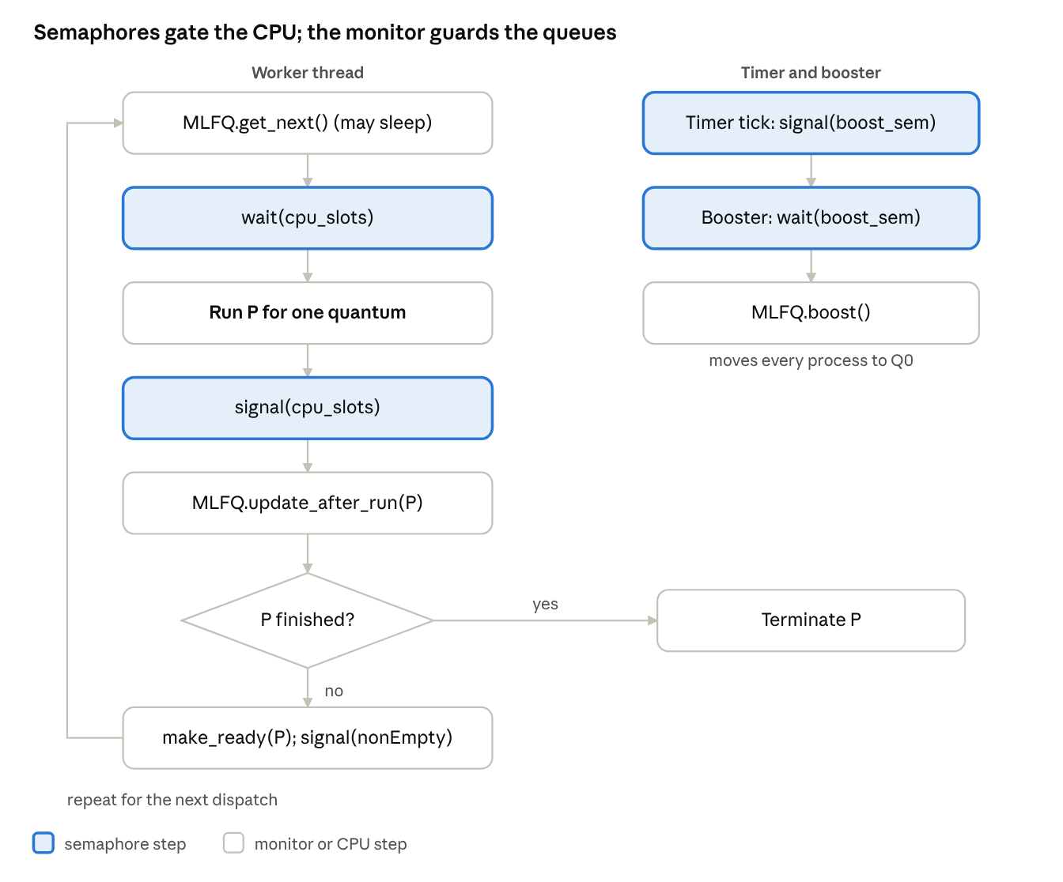
hybrid worker and booster · semaphore vs monitor steps
Semaphore steps are tinted: the worker takes and returns a core slot outside the monitor, and the timer tick reaches the booster through boost_sem without ever entering the monitor.

7. Worked Example (Two Cores)
Three processes arrive at time 0 and the system has M = 2 cores. Quanta are 4, 8 and 16 ms.
Process | Burst (ms) | Behavior
A | 20 | CPU-bound
B | 6 | Short, interactive
C | 12 | Medium
Execution trace:
Interval | Core | Process | Queue | Result
0-4 | 1 | A | Q0 | Quantum expires; A moves to Q1 (remaining 16)
0-4 | 2 | B | Q0 | Quantum expires; B moves to Q1 (remaining 2)
4-8 | 1 | C | Q0 | Quantum expires; C moves to Q1 (remaining 8)
4-12 | 2 | A | Q1 | Quantum expires; A moves to Q2 (remaining 8)
8-10 | 1 | B | Q1 | B finishes at 10
10-18 | 1 | C | Q1 | C finishes at 18
12-20 | 2 | A | Q2 | A finishes at 20
Semaphore and monitor state at selected instants:
Time | cpu_slots | ready_count | Event
0 | 0 | 1 | Two workers hold both cores; C waits in Q0
10 | 0 | 0 | Core 1 starts C, core 2 still runs A
18 | 1 | 0 | C finished and released its slot
20 | 2 | 0 | All work done; workers sleep on nonEmpty
Resulting metrics:
Process | Completion | Turnaround | Waiting
A | 20 | 20 | 0
B | 10 | 10 | 4
C | 18 | 18 | 6
Average |  | 16.0 | 3.3
With two cores the average turnaround falls from 30.0 ms (single core) to 16.0 ms, and the semaphore guarantees that never more than two processes run at once.

8. Correctness Analysis
Mutual exclusion on scheduling state. Every access to Q[i] and ready_count happens inside a monitor procedure, so only one thread manipulates them at a time.
Core capacity invariant. cpu_slots starts at M, each running process holds exactly one unit between wait and signal, so at most M processes run simultaneously and the value always stays between 0 and M.
No lost work. Because get_next tests ready_count under the monitor lock before waiting, a make_ready signal cannot slip between the test and the wait.
No lost timer tick. A tick that arrives while the booster is busy increments boost_sem, so the booster performs the boost afterwards. If several ticks pile up, the booster boosts several times in a row, which is harmless because boosting is idempotent.
Deadlock freedom. The monitor lock and the semaphore are never held in a nested way: a worker leaves the monitor before waiting on cpu_slots, and it releases cpu_slots before re-entering the monitor. The monitor never waits on a semaphore. Hence no circular wait exists.
Starvation freedom. The booster moves every ready process to Q0 once per period S, so each process runs within a bounded time.

9. Performance Considerations
Aspect | Observation
Lock hold time | The monitor is held only for bookkeeping; the CPU burst runs outside it.
Interrupt latency | The handler does a single signal, so interrupt latency stays minimal.
Core utilization | W greater than M keeps cores busy while other workers are inside the monitor.
Contention | One monitor lock is shared; use one hybrid scheduler per core group on large machines.
Busy waiting | None; workers sleep on nonEmpty and the booster sleeps on boost_sem.
Complexity | More primitives to understand, but each has a narrow, clear job.

10. Comparison of the Three Approaches
Criterion | Semaphores only | Monitor only | Hybrid
Queue protection | Per-queue binary semaphores | Monitor lock | Monitor lock
Waiting for work | Counting semaphore ready | Condition variable | Condition variable
Limiting running processes to M cores | Extra counting semaphore | Extra counter and condition | Counting semaphore cpu_slots
Timer-to-booster signaling | Semaphore or shared flag | Flag, lock needed in handler | Semaphore boost_sem
Deadlock risk | Needs lock ordering | Single lock, minimal | Avoided by the no-nesting rule
Programmer error risk | High | Low | Medium
Readability | Medium | High | High
Best suited for | Teaching primitives, simple kernels | Single-lock designs, Java and C# | Multicore kernels with interrupts

11. Conclusion
The hybrid scheduler keeps the strengths of both primitives. The monitor gives MLFQ a clear, safe home for its queues and policy, while semaphores handle what they do best: counting free cores and passing timer ticks from an interrupt handler. One rule, never waiting on a semaphore inside the monitor, is enough to rule out deadlock. The two-core example showed the expected behavior, with short jobs finishing early and the semaphore bounding concurrency. For multicore systems with interrupt-driven priority boosting, the hybrid is the most practical of the three designs presented in this series.

References
- Hoare, C. A. R. Monitors: An Operating System Structuring Concept, Communications of the ACM, 1974.
- Dijkstra, E. W. Cooperating Sequential Processes, 1965.
- Lampson, B. W., and Redell, D. D. Experience with Processes and Monitors in Mesa, Communications of the ACM, 1980.
- Arpaci-Dusseau, R. H., and Arpaci-Dusseau, A. C. Operating Systems: Three Easy Pieces, Wisconsin.
- Silberschatz, A., Galvin, P. B., and Gagne, G. Operating System Concepts, Wiley.

